Functions & Relations Practice Worksheet
Identifying Functions • Vertical Line Test • Graphing Equations • Function Notation
Name: ____________________ | Date: _____________ | Class: _____________

Section 1: Relations vs. Functions (Tables & Sets)
Instructions: State whether each relation represents a function. Explain your reasoning.
1. Set A: {( -3, 4 ), ( -1, 2 ), ( 0, 5 ), ( 2, 4 ), ( 5, 1 )}
Is this a Function? ____________ Reason: __________________________________________________
2. Set B: {( -2, 1 ), ( 1, 3 ), ( 1, -4 ), ( 3, 7 ), ( 6, 0 )}
Is this a Function? ____________ Reason: __________________________________________________
3. Input/Output Table:
Input (x) | -4 | -2 | 0 | 2 | 4
Output (y) | 16 | 4 | 0 | 4 | 16
Is this a Function? ____________ Reason: __________________________________________________
Section 2: The Vertical Line Test (Graph Analysis)
Instructions: Use the Vertical Line Test (VLT) on each graph. Determine if the graph represents a function.
4. Circle Relation  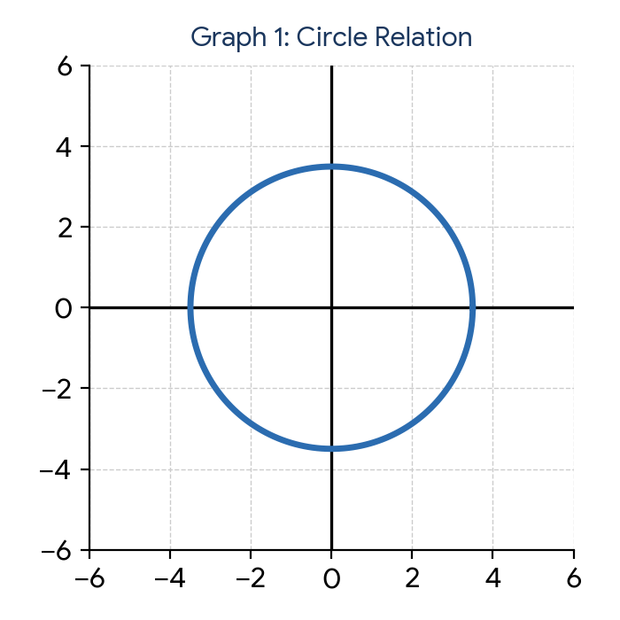  Function? [ Yes / No ]  Reason: ___________________ | 5. Linear Relation  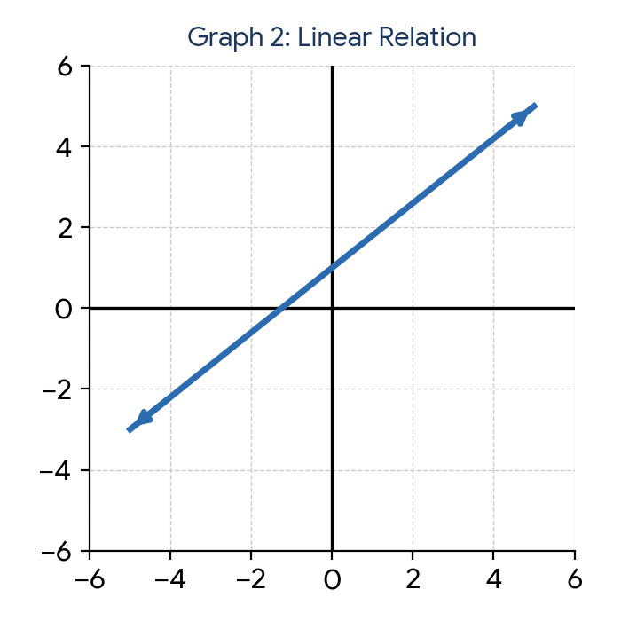  Function? [ Yes / No ]  Reason: ___________________
6. Sideways Parabola  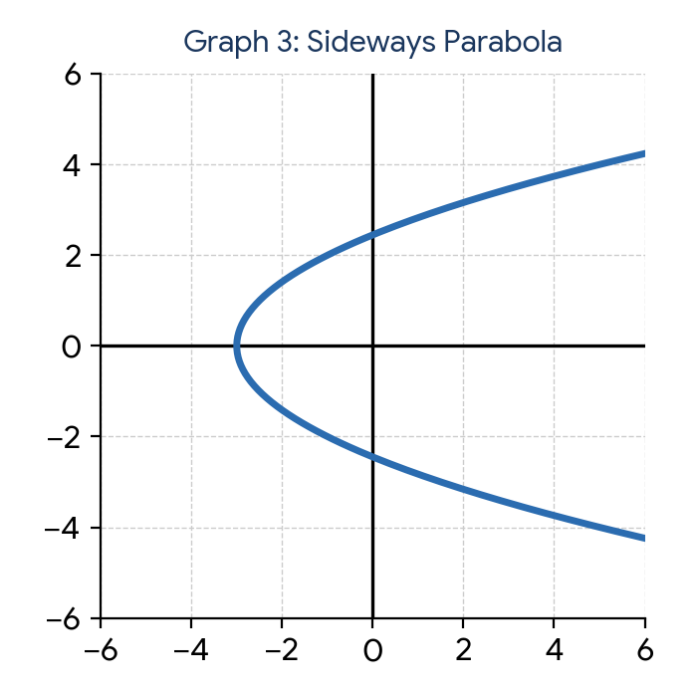  Function? [ Yes / No ]  Reason: ___________________ | 7. Absolute Value  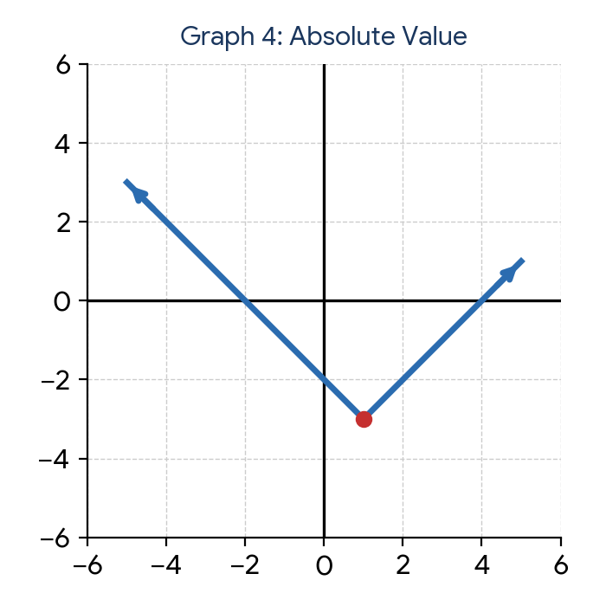  Function? [ Yes / No ]  Reason: ___________________

Section 3: Graphing Functions from Equations
Instructions: Complete the table of values, plot the points on the grid provided, and sketch the graph.
8. f(x) = 2x - 3 (Linear Function)
Table of Values: | 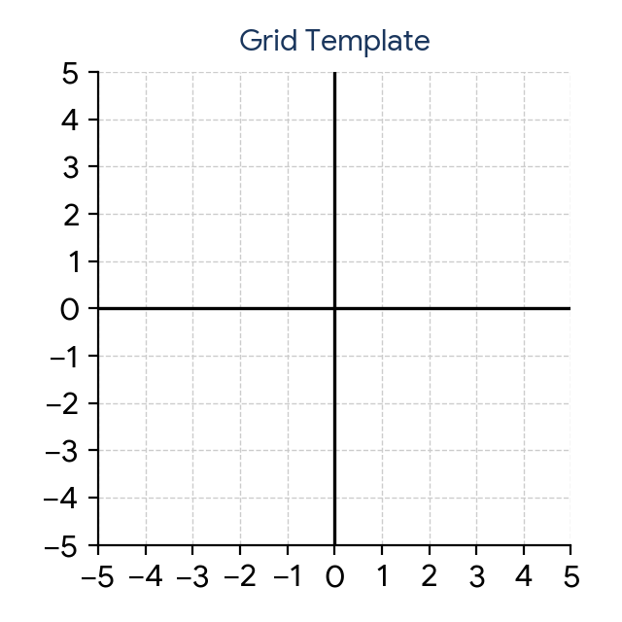
  x | y
  -2
  -1
  0
  1
  2
9. g(x) = x² - 4 (Quadratic Function)
Table of Values:
x | y
-2
-1
0
1
2

10. h(x) = |x + 1| - 2 (Absolute Value Function)
Table of Values:
x | y
-2
-1
0
1
2

Section 4: Evaluating Functions
Given the functions below, evaluate each expression:
f(x) = 3x - 5, g(x) = x² + 2x, h(x) = √(x + 9)
11. f(4) = ________________________ | 12. g(-3) = ________________________
13. h(16) = ________________________ | 14. f(-2) + g(3) = ________________________
15. Find x if f(x) = 13: ____________ | 16. g(a + 1) = ________________________

